- Program ID : VS003MA1

- Display Layout
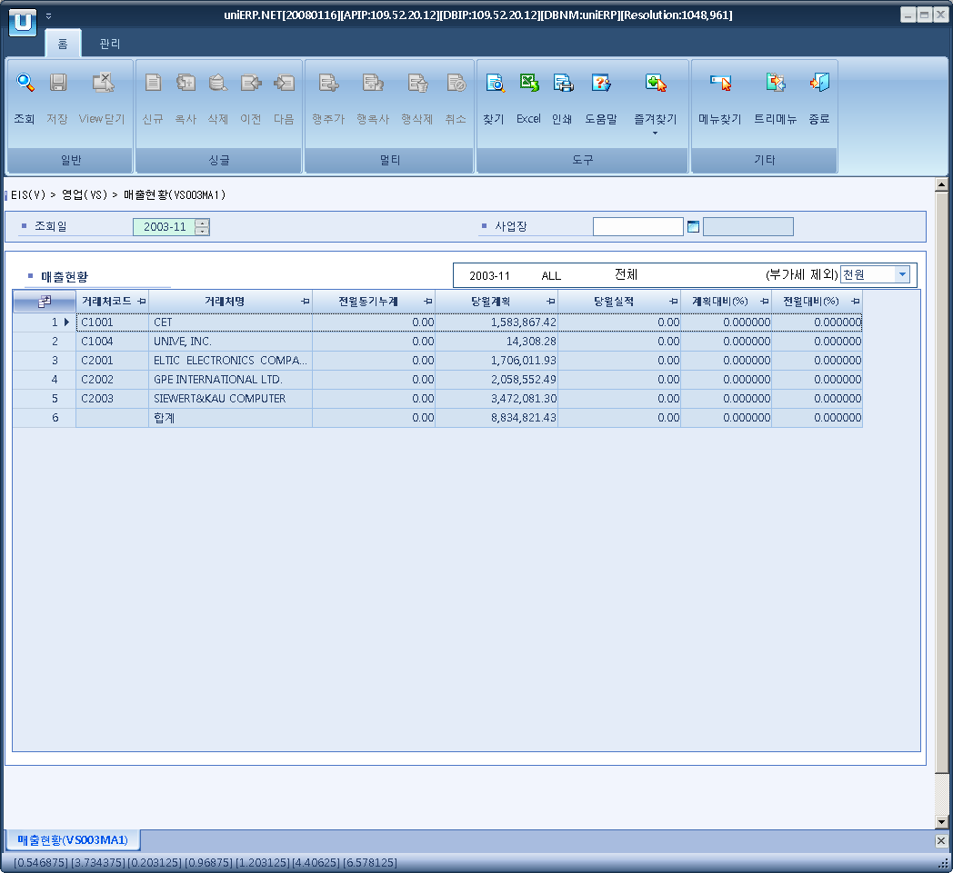

- Event flow
- Click Query button
- OnFncQuery -> DbQuery -> DataChange
- Display Unit combo change
- uniCombo1_ValueChanged -> DataChange

- SQL Statements
- Sales status
SELECT a.sold_to_party AS bp_cd, a.bp_nm,
ISNULL(SUM(a.pre_amt), 0) AS pre_amt,
ISNULL(SUM(a.pln_amt), 0) AS pln_amt,
ISNULL(SUM(a.cur_amt), 0) AS cur_amt,
CASE WHEN ISNULL(SUM(pln_amt), 0) = 0 THEN 0
ELSE ISNULL(SUM(cur_amt), 0) / ISNULL(SUM(pln_amt), 0) * 100
END AS plnRate,
CASE ISNULL(SUM(pre_amt), 0) WHEN 0 THEN 0
ELSE ISNULL(SUM(cur_amt), 0) / ISNULL(SUM(pre_amt), 0) * 100
END AS preRate
FROM (SELECT a.sold_to_party, b.bp_nm,
0 AS pre_amt, SUM(a.amt_loc) AS pln_amt, 0 AS cur_amt
FROM s_sp_item_by_bp a
INNER JOIN b_biz_partner b
ON b.bp_cd = a.sold_to_party
INNER JOIN b_sales_grp d
ON d.sales_grp = a.sales_grp
INNER JOIN b_cost_center c
ON c.cost_cd = d.cost_cd
AND c.biz_area_cd LIKE @biz_area_cd
WHERE a.sp_period = @strYyyymm
GROUP BY a.sold_to_party, b.bp_nm
UNION ALL
SELECT a.sold_to_party, b.bp_nm, 0,
SUM(CASE WHEN a.bill_dt BETWEEN DATEADD(MONTH, -1, @strYyyymm + '01')
AND DATEADD(DAY, -1, @strYyyymm + '01') THEN a.bill_amt_loc
ELSE 0
END) AS pre_amt,
SUM(CASE WHEN a.bill_dt BETWEEN @strYyyymm + '01'
AND DATEADD(DAY, -1, DATEADD(MONTH, 1, @strYyyymm + '01')) THEN a.bill_amt_loc
ELSE 0
END) AS cur_amt
FROM s_bill_hdr a
INNER JOIN b_biz_partner b
ON b.bp_cd = a.sold_to_party
WHERE a.bill_dt BETWEEN DATEADD(MONTH, -1, @strYyyymm + '01')
AND DATEADD(DAY, -1, DATEADD(MONTH, 1, @strYyyymm + '01'))
AND a.biz_area LIKE @biz_area_cd
GROUP BY a.sold_to_party, b.bp_nm) a
GROUP BY a.sold_to_party, a.bp_nm'1'

